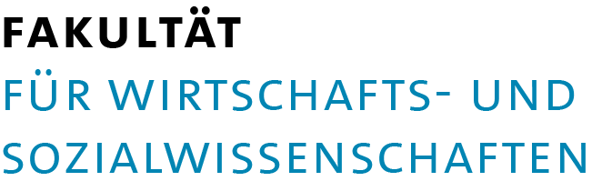

Studienbüro Volkswirtschaftslehre

Incoming Students – Course Enrollment Summer Term 2018
Please fill in this application form and submit it to the responsible program coordinator until 12.04.2018 at the latest.
First Name |  | Last Name |  | Matriculation Number (University of Hamburg)
E-mail |  | Study Program (sending University) |  | Study Program (University of Hamburg)

 |  | Course Information
Number | Course Title |  | Lecturer | Zug (only relevant for VWL) | Tutorial: ÜB Number, Day, Time  (only relevant for VWL)

Date |  | Student‘s Signature |  | Date |  | Program Coordinator’s Signature

